An Overview of Siren Sounds and Complaints in NYC

In light of CM Brewer's and CM Louis's bill (Int 0082-2026) to conduct a study to determine the places and times where siren noise is most common in NYC, the Data Team has analyzed the limited data that already exists on this subject.

Executive Summary

The Data Team’s analysis of Sounds of NYC (SONYC) siren data and siren-comparable 311 complaints came to the following conclusions regarding street noise in 2016-2019:
- The highest quantity of sirens were heard in Greenwich Village and Union Square.
- Sirens were most common relative to other sounds in Downtown Brooklyn.
- There is no evidence for seasonality in the times when sirens were heard.
- Residents were most likely to complain to 311 about construction and vehicle noise in affluent and highly trafficked parts of Manhattan, though alarms and car horns were the subject of many more complaints in Hillcrest and Pomonok, Queens.

We also advocate for more complete and current data to better target siren sounds. To do so, it is possible to utilize existing surveys such as DOHMH’s Community Health Survey or real-time reporting as seen in DEP’s NYC Noise mobile app.

Existing Data Landscape

Although there is currently no formal study of siren noise in NYC, the NYC Noise mobile app launched by DEP in the fall of 2025 could be a valuable resource in the future. The app allows users to record and classify sound data (including sirens) to better understand citywide noise patterns. Its data is not yet available, but it will eventually be well-suited for examining the frequency of siren sounds across the city.

We found that the best information that's currently available comes from the Sounds of NYC (SONYC) study conducted by NYU and Ohio State University between May 7th, 2016 and December 31st, 2019. This study placed 56 sensors across Manhattan, Brooklyn, and Queens and annotated the sounds they heard, including sirens, with the goal of enabling city decision-makers to identify noise patterns across the city. The reported data does not go past 2019 and covers a limited portion of NYC, but provides valuable insight for the times and places where it is available.

We supplemented the SONYC data with 311 complaint data. Though 311 does not and cannot respond to siren-related complaints, we used Street Noise 311 complaints from the SONYC study period to supplement the data and better represent the five boroughs. We approximated the disturbance caused by sirens with complaints related to other intrusive street noises: construction, engine idling, car horns, and alarms. By studying the location and timing of these types of complaints, we reached a broader understanding of NYC's loudest streets from 2016 to 2019.

Findings

SONYC - When analyzing the SONYC data, we checked weekly, monthly, and yearly trends in the number of sirens heard by the sensors throughout the city. Timeseries analysis did not reveal a seasonal pattern: siren sounds were not more or less prevalent at different times of year. Data was available at the hourly level, and we found that the most sirens were heard between 11am and 9pm, peaking at 2pm. The fewest sirens were heard at 3am.
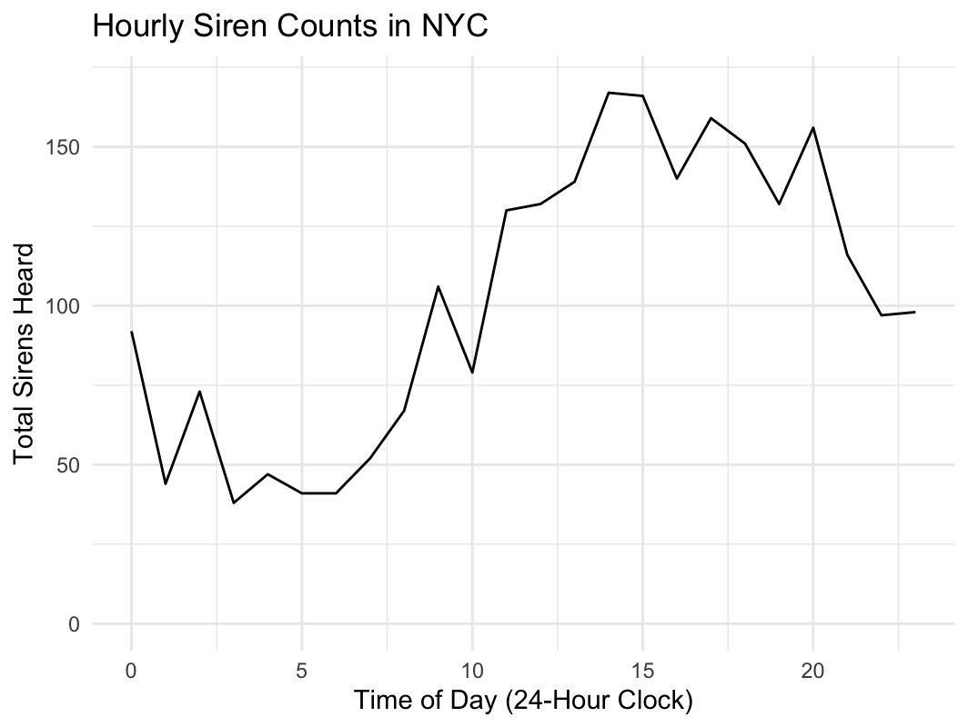

Our spatial findings are summarized in the map below. Each dot represents a sensor. The size of the dots corresponds to the number of sirens the sensor heard throughout the study period, with the most sirens being heard in the main Manhattan cluster. The shade of the dots corresponds to the percentage of sounds the sensor heard that were sirens, with the highest rates occurring in Downtown Brooklyn. The dots outlined in blue, found only in Downtown Brooklyn, represent a statistically significant hotspot of higher siren rates. This was determined by the Gi* statistic, which identifies clusters of high values across a geographic area. The data show that although the most sirens were heard in Greenwich Village and Union Square, sirens were more common relative to other sounds in Downtown Brooklyn.
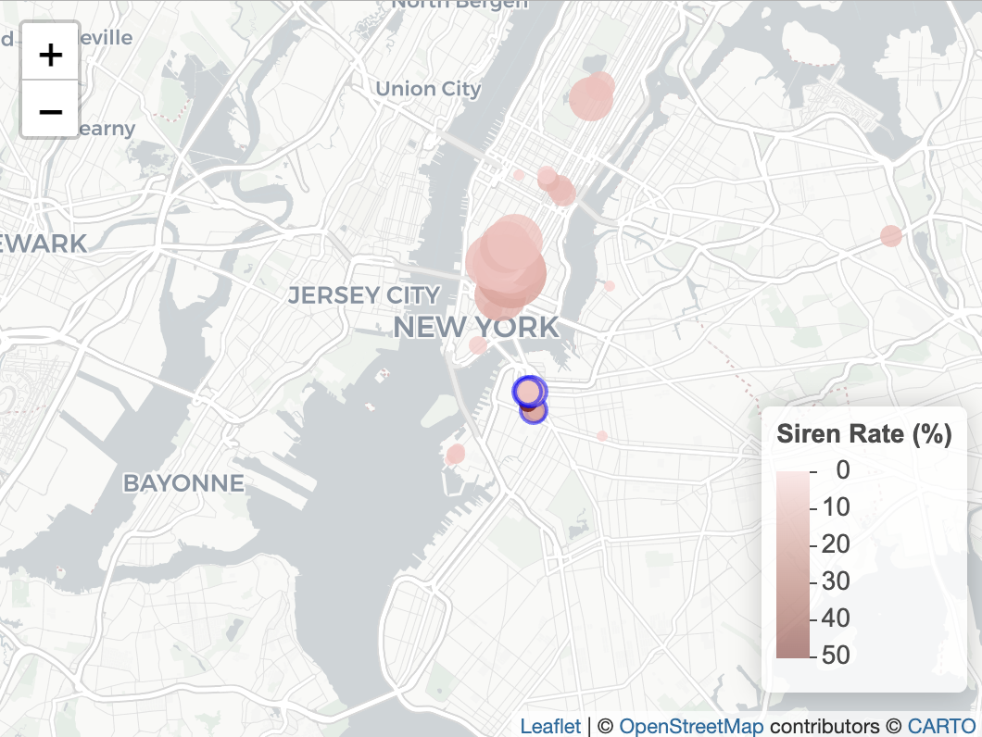

311 Data – We performed the same timeseries analysis when analyzing 311 complaints relating to noisy streets. This time a seasonal component was present, but it was based largely on construction ebbs and flows and does not translate to a straightforward time of year. The graph below shows the pattern of construction, vehicle, and alarm noise during the SONYC study period, with a trendline in blue. Complaints often peak in the spring months and October, with the lowest values recorded in the summer months and December.
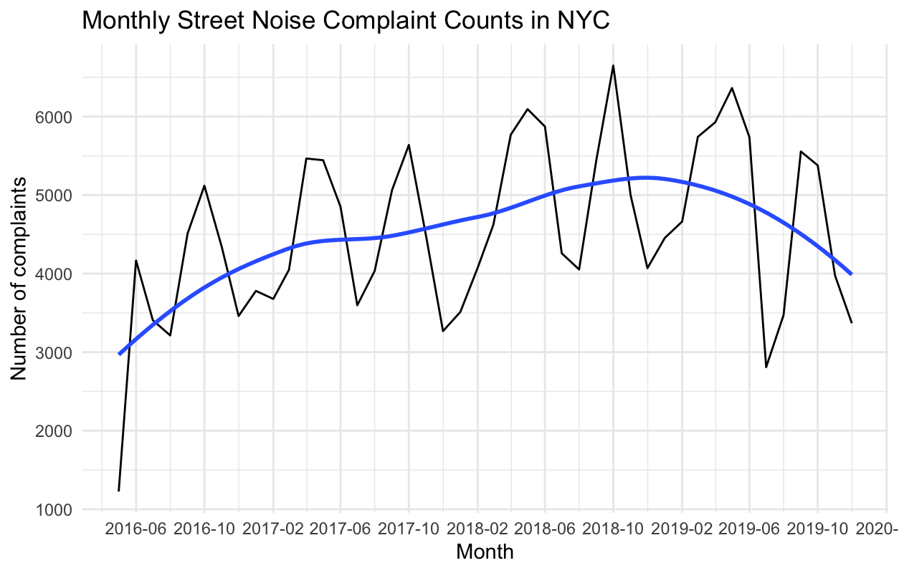
The map below shows our spatial findings for 311 complaints at the Neighborhood Tabulation Area (NTA) level. Aside from a notable outlier discussed later, the NTAs with the most street noise complaints per capita center around Midtown, Hudson Square, and Tribeca. The blue dots are hotspots with significantly high Gi* statistics, and outside of the outlier, they present a revealing pattern. The hotspots cluster around entry points to Manhattan (the Holland, Lincoln, and Queens-Midtown Tunnels) and places of dense traffic and urban activity (the Financial District and Columbus Circle). The complaint hotspots are also in wealthier areas, which other studies have found to be more likely to complain to 311. We do not see as many complaints in Chinatown, the Lower East Side, or Washington Heights, despite these neighborhoods containing bridges with high levels of traffic and construction.

The NTA with the most street noise complaints per capita was Pomonok-Electchester-Hillcrest in Queens, part of Council District 24 (CM Gennaro). This is a notable outlier, with over 2.5x the rate of complaints as the next-highest NTA, Midtown-Times Square. It features a higher rate of car horn-related complaints compared to the rest of the city (59% vs. 16%), many of which may be related to pick up and drop off traffic at a nearby yeshiva. Alarm complaints are also more prevalent here, accounting for 33% of street noise complaints compared to 8% citywide. 43% of all alarm complaints from the study period originated here. Many of these alarm complaints were likely siren-related, considering the proximity of clusters of 1,000+ complaints to Queens Hospital Center and FDNY Engine 315. These hospitals and fire stations are both close to residential areas. Though this is the case for many such facilities in NYC, the combination of noise-prone institutions and a complaint-inclined residential population may help to explain the NTA’s outlier status.

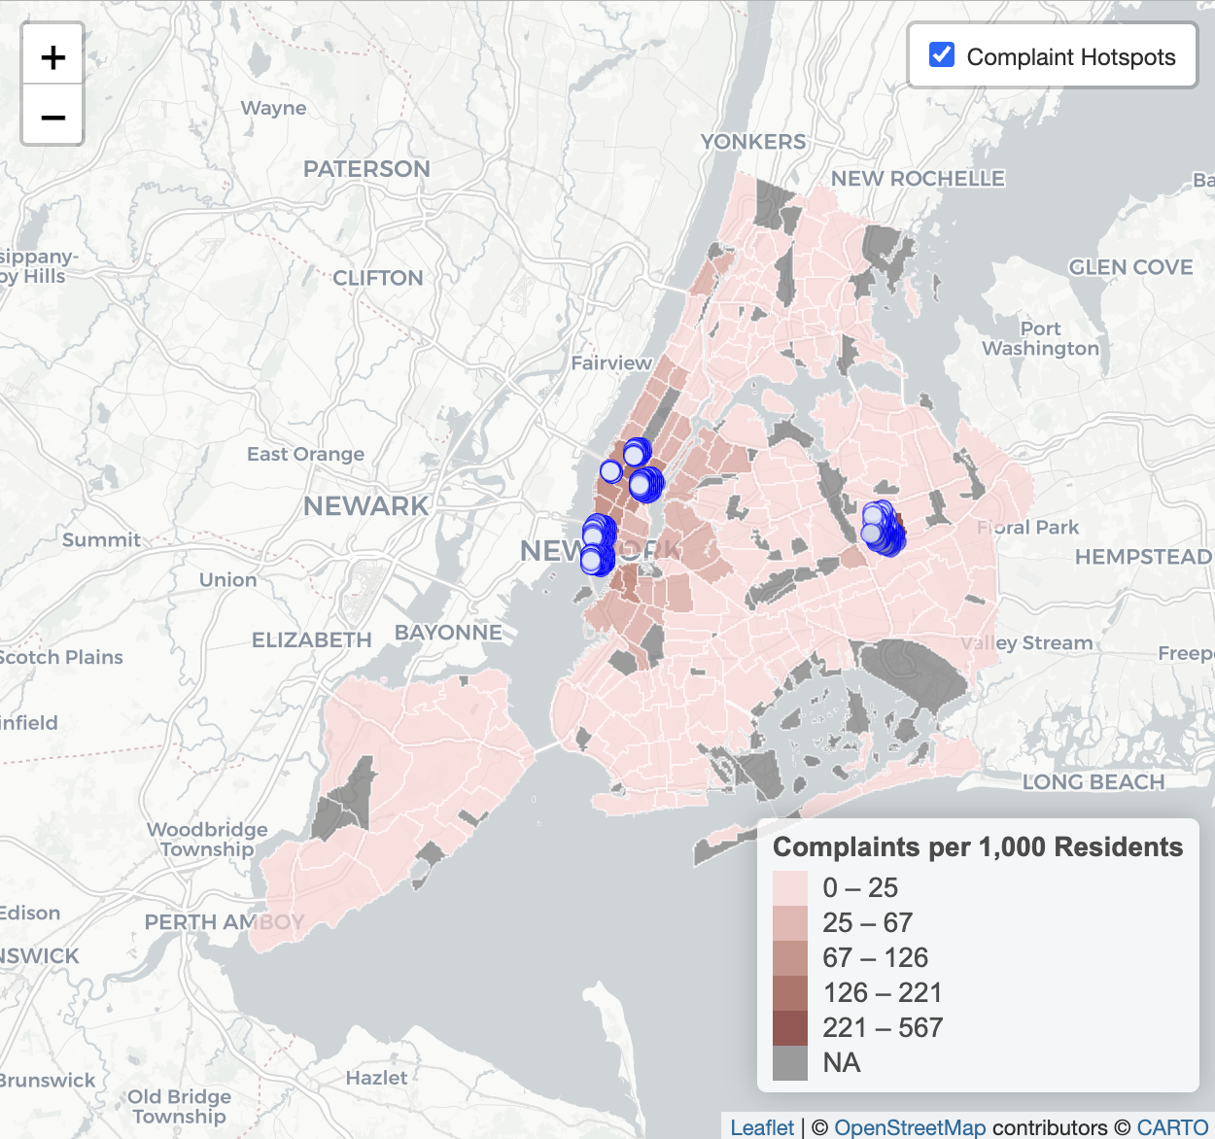

Conclusions & Data Recommendations

The limited data currently available shows that as of 2019, although many sirens could be heard in Greenwich Village and Union Square, sirens were most common relative to other sounds in Downtown Brooklyn. We did not discover significant seasonality in the times when sirens were heard. Examining 311 complaints relating to similar street noise from this period revealed that residents are most likely to complain about construction and vehicle noise in affluent and highly trafficked parts of Manhattan, though alarms and car horns were the subject of many more complaints in Hillcrest and Pomonok, Queens. Assuming these trends still hold today, all the places mentioned in this paragraph would be strong candidates for interventions to reduce street noise.

More complete and recent data is necessary to target siren sounds. A survey asking people about their experience with siren noise would allow us to identify areas where sirens pose the biggest nuisance, whereas the upcoming NYC Noise app data will distinguish the areas where sirens are most commonly heard and reported. Both would better enable us to carry out analyses like this one.

We recommend utilizing existing surveys to determine the prevalence of siren sounds in the city. DOHMH's Community Health Survey (CHS) already has the necessary resources and scope to reliably answer questions like this by surveying a representative sample of New Yorkers. The CHS previously included a question asking which sources of noise have recently been disruptive to respondents, including sirens. Reintroducing this question, last asked in 2009, alongside similar questions about sirens, would be a viable way to collect the information Int 82 is interested in.

We hope this analysis offers insight regarding the tools currently available to measure the impact of sirens on New Yorkers and the best next steps for pursuing improved data.

